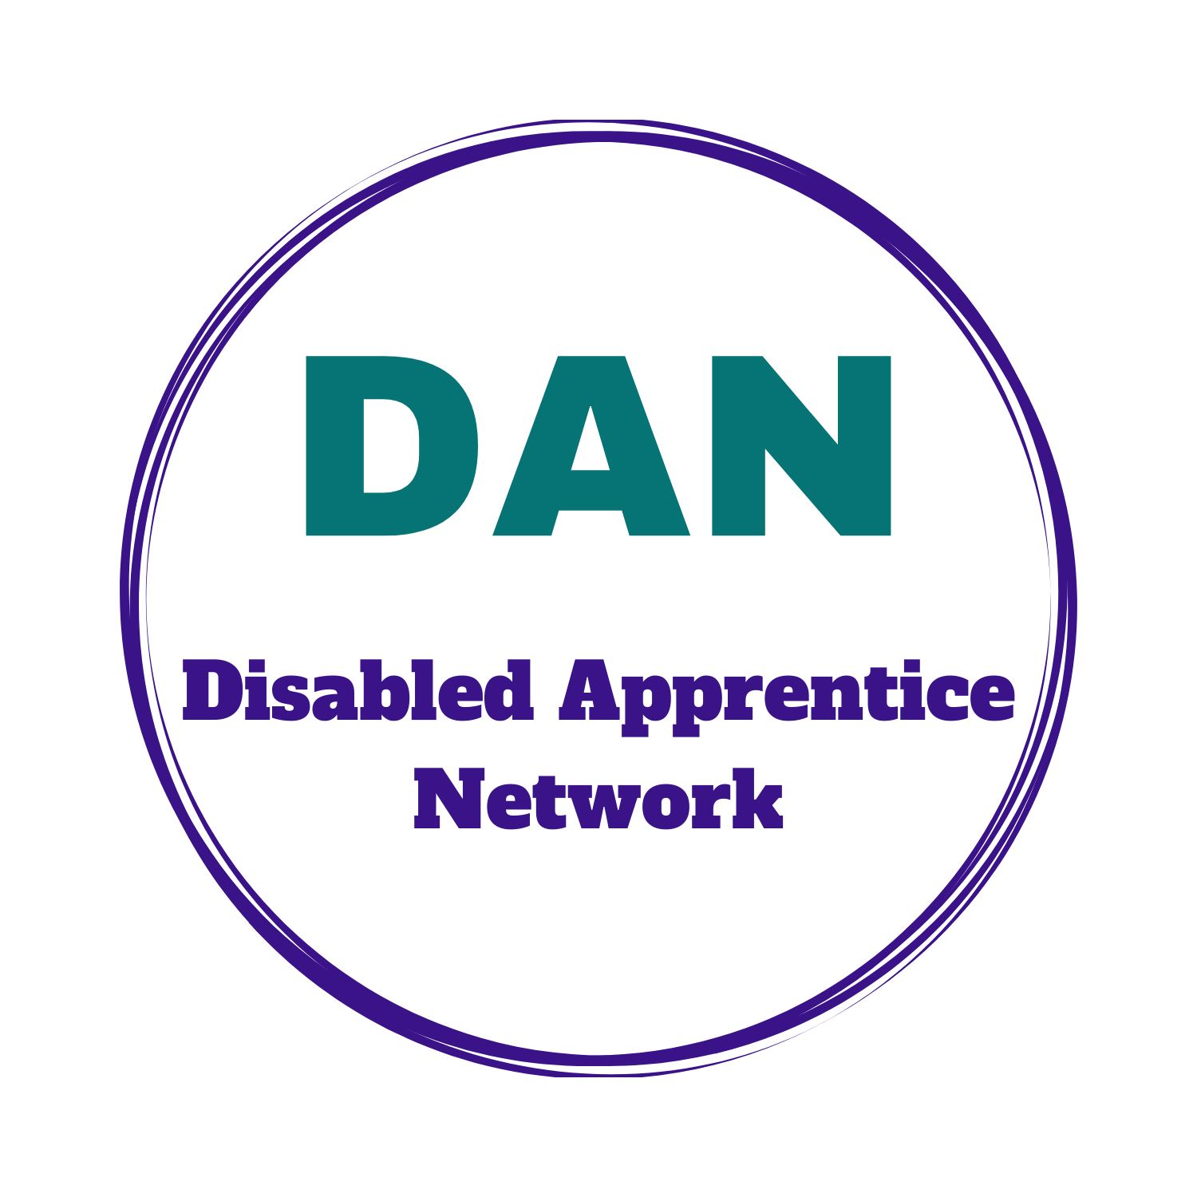
The Disabled Apprentice Network

The Disabled Apprentice Network (DAN) brings together Disabled apprentices and those who have finished their apprenticeship

The Network is a lively and friendly forum for Disabled apprentices, to share their experiences and to offer views and proposals on what could improve apprenticeships for Disabled people.
Join the Disabled Apprentices Network (DAN)
The Network meets monthly online for an hour. The discussion topics are varied, including barriers to apprenticeships, support and reasonable adjustments, access to information, communication with employers and training providers.
There is always time for Network members to raise their own concerns and priorities.
The Network produces an annual report for National Apprenticeship week. Last year’s report is available from the Disability Rights UK’s website: Disabled Apprentice Network
If you would like to join the Network or find out more, please contact rabia.lemahieu@disabilityrightsuk.org
Disability Rights UK is an organisation led by, run by, and working for Disabled people and runs different projects informed by the lived experience of Disabled people.

