**National Apprenticeship Week 2025**

**10th – 16th February 2025**

**Activity pack for students**

_________________________________________________

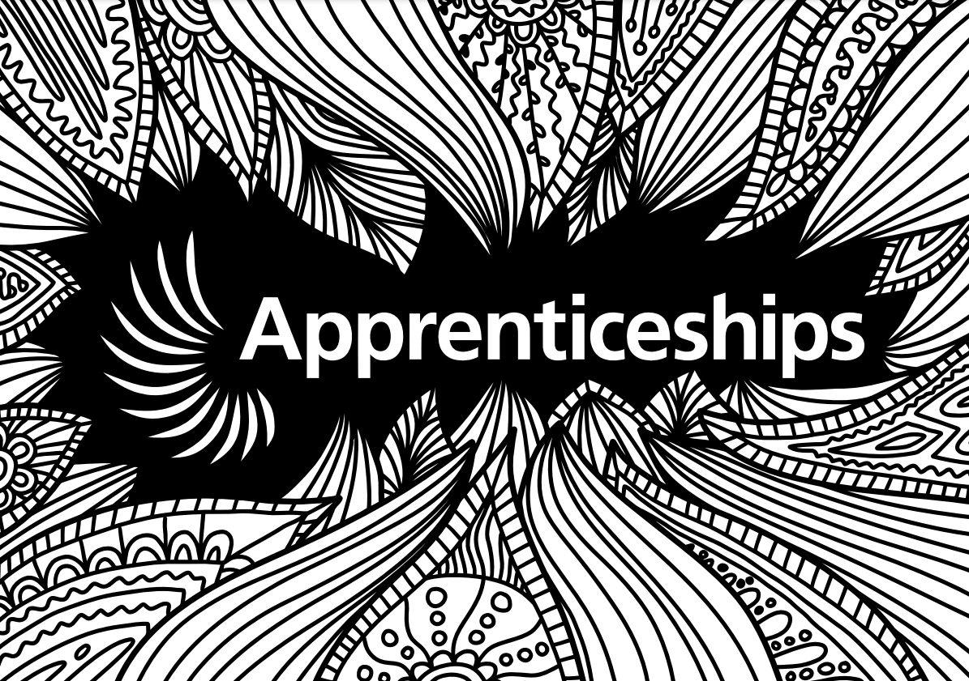

Name:

Class:

_________________________________________________

**Introduction**

National Apprenticeship Week is a fantastic opportunity for you to learn more about apprenticeships and how they might be an exciting option for you when you leave school or college. Following the instructions of your teacher, work your way through this activity pack to begin exploring what apprenticeships are, which apprenticeships are available and to learn about the exciting careers apprenticeships can lead to.

Please note that some tasks will require access to a computer and the internet.

**Social media:** [@Apprenticeships](https://twitter.com/apprenticeships) **Hashtag:** #NAW2025

**Contents**

**Activity sheet 1**: Apprenticeships quiz – two truths and a lie 3

**Activity sheet 2**: Apprenticeship employer wordsearch 4

**Activity sheet 3**: Hear from apprentices 5

**Activity sheet 4**: Find the missing word 6

**Activity sheet 5**: Apprentice employer logos 7

**Activity sheet 6**: The Big Assembly 8

**Activity sheet 7**: Apprenticeships rebus puzzle 9

**Activity sheet 8**: Unscramble the apprenticeship job roles 10

**Activity sheet 9**: Five, four, three, two, one… 11

**Activity sheet 10**: Apprenticeships crossword 12

**Top tips for exploring apprenticeships**

To continue learning about apprenticeships and the exciting   
careers available, visit: [www.apprenticeships.gov.uk](http://www.apprenticeships.gov.uk)

The government has a fantastic website where you can learn   
more about the range of apprenticeships available, how to   
search and apply for apprenticeships, what roles are available   
and more. You can also hear real stories from   
apprentices about their experiences.

Click the link above or scan the QR code to visit now.

______________________________________________

**TASK 1: Two truths and a lie**

**To complete this task, please follow these instructions:**

* Look at these sets of statements about apprenticeships.
* Decide which two are true and which one is a lie!
* Write truth or lie next to each statement.
* Use the internet to research if you get stuck, for example by visiting: [www.apprenticeships.gov.uk/apprentices/becoming-apprentice](http://www.apprenticeships.gov.uk/apprentices/becoming-apprentice)

|  |  |
| --- | --- |
| You can only complete one apprenticeship in your career. |  |
| There is no limit on the number of apprenticeships you can do in your career. |  |
| You can do one level of apprenticeship and then another level later on. |  |

|  |  |
| --- | --- |
| Apprentices earn a salary. |  |
| Apprentices are entitled to holiday pay. |  |
| Apprentices are not entitled to benefits like company cars or gym memberships. |  |

|  |  |
| --- | --- |
| Apprentices have the equivalent 6 hours a week of ‘off-the-job’ learning time. |  |
| Apprentices are not paid for their ‘off-the-job’ learning time. |  |
| Apprentices are paid for their ‘off-the-job’ learning time. |  |

|  |  |
| --- | --- |
| Apprentices don’t pay any fees towards their studies. |  |
| Apprentices pay all the fees for their studies. |  |
| The Government and the employer pay the fees for an apprentice’s studies. |  |

|  |  |
| --- | --- |
| You can undertake an apprenticeship if you are over 16 years old and not in full-time education. |  |
| There is no upper age limit for apprentices. |  |
| You can only do an apprenticeship between the ages of 16 and 24. |  |

|  |  |
| --- | --- |
| Only large companies offer apprenticeships. |  |
| There are apprenticeships across every sector and industry. |  |
| There are more than 700 different apprenticeship standards available. |  |

_________________________________________________

**TASK 2: Apprenticeship employer wordsearch**

**To complete this task, please follow these instructions:**

* Not sure if there is an apprenticeship employer to suit your interests? There are thousands of apprenticeship employers in England across a broad range of industries.
* Below is a list of some of the Top 100 Apprenticeship Employers in 2024. See if you can locate them all in the grid (some may be on two lines next to each other).
* You can explore the Top 100 Apprenticeship Employers here: <https://topapprenticeshipemployers.co.uk/>

**FIND:**

Amazon

BAE Systems

BBC  
British Army

BT

Busy Bees Nurseries

Caroola

Deloitte

Home Office

HSBC

John Lewis

McDonalds

Ministry of Defence

PWC

Royal Air Force

Royal Navy

Screwfix

Specsavers

Superdrug

Tesco

**Bonus question:**

Which of these apprenticeship employers has been the number one apprenticeship employer for the last four years?



_________________________________________________

**TASK 3: Hear from apprentices**

**To complete this task, please follow these instructions:**

* A great way to find out more about what apprenticeships are really like is to hear from real apprentices.
* Click here [www.amazingapprenticeships.com/ncw](http://www.amazingapprenticeships.com/ncw) to find lots of different apprentice story films.
* Watch the films below, work out who said what and write their name on the line under the speech bubble – Nana, Daisy, Kelby or James.

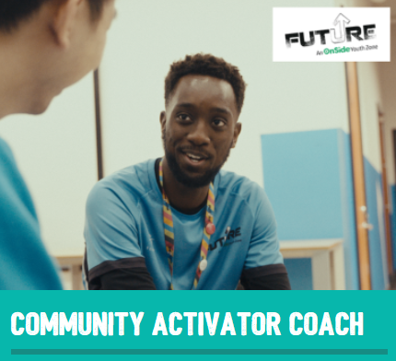**

James

Level 6 Software Engineer Apprentice

Kelby

Level 5 Nursing Associate Apprentice

Daisy

Level 3 Fundraiser Apprentice

Nana

Level 2 Community Activator Coach Apprentice

Now watch any of the other films on the page that interest you!

[www.amazingapprenticeships.com/ncw](https://amazingapprenticeships.com/ncw2024/)

I would recommend an apprenticeship as it takes the stress off you having to pay back a student loan.

____________________

I feel really privileged to be working here, it’s really cool to be a part of it really.

____________________

____________________

The way I became an apprentice was I went for a recruitment event day.

Every week I have a study day, where I just do all my university studies and tutorials.

My line manager and employer have supported me so well, they’ve made adjustments to meet my needs.

____________________

I like being able to help people and seeing the good that we do as a charity.

____________________

____________________

An apprenticeship allows you to gain experience before you’re fully qualified, so I’ve been able to gain experience in all different fields.

____________________

____________________

I wanted to expand my knowledge and just get back into learning because I really enjoyed uni. The apprenticeship’s been really helpful in helping me achieve my role here.

_________________________________________________

**TASK 4: Find the missing word**

**To complete this task, please follow these instructions:**

* Nivia is a Level 3 Business Administration apprentice at The Hyde Group and has shared her experience below.
* Read Nivia’s story and insert the correct words from the word bank into her story.
* If you are completing this online, please type in the space.

Tell us a bit about your role.

My role as an ________________________ in the Transformation Team is typically to assist with Project Management Office (PMO) activities. I offer support on a range of different projects such as Building Safety, The Digital Programme and the Umbraco Upgrade (a content management platform). My role is very similar to a project coordinator's role. I began this job role in September 2022 and I have been enjoying it ever since. My ultimate goal is to become a project ________________________ and make my family proud!

Why did you choose to do an apprenticeship?

I decided to go down the apprenticeship route because I wanted to get my foot in the project management door, whilst combining theoretical learning with ________________________ on the job.

How did you go about finding an apprenticeship?

I searched through a range of different websites such as Gov.uk, Google, Indeed, Not Going to Uni, Multiverse and so on. I found the apprenticeship that I am currently doing on Indeed. The ________________________ process was quite challenging, but I persevered through and did not give up! I was drawn to social housing because it is such a broad ________________________ with opportunities for career ________________________.

How is your apprenticeship delivered?

My ________________________ provider is Remit Training. All learning takes place virtually and I meet with my ________________________ coach once a month for two hours. I get a day a week from my company solely for my ________________________ work!

Who or what inspires you and what is your proudest achievement?

My inspiration is my grandmother! She was very ________________________ before she retired and left everything in Jamaica to begin a new life over in England. My proudest achievement for my apprenticeship so far would be receiving the “Hyde Rising Star” Award at the Aspire awards held by my company. It was nice to be recognised for all my efforts. In my spare time I enjoy cooking, listening to music and sleeping.

What would your advice be to others about apprenticeships?

Do more ________________________ surrounding apprenticeships before shutting the idea down. University is not made for everyone and sometimes being thrown in the deep end at a company brings out hidden ________________________ within someone (like it did with me). Apprenticeships are amazing ________________________!

|  |
| --- |
| **Word bank** |

application apprentice apprenticeship development hardworking industry learning manager opportunities progression research talents training

_________________________________________________

**TASK 5: Apprentice employer logos**

**To complete this task, please follow these instructions:**

* There are hundreds of employers who offer apprenticeships in England, from a range of sectors and of all sizes.
* Can you recognise the logos of these amazing apprentice employers?
* Work with a partner or on your own to identify which company each logo represents.
* If you are completing this online, please type in the space.



|  |  |  |
| --- | --- | --- |
|  | UK Parliament Reveals New Logo Design ... |  |
|  |  |  |
| Dunelm Logo [ Download - Logo - icon ] png svg |  |  |
|  |  |  |
|  |  |  |
|  |  |  |
|  |  |  |
|  |  |  |
|  |  |  |
|  |  |  |

Discover more at [www.amazingapprenticeships.com/vacancies](http://www.amazingapprenticeships.com/vacancies)

_________________________________________________

**TASK 6: The Big Assembly**

**To complete this task, please follow these instructions:**

* This task will need to be completed after **11:10am on Tuesday 11th February 2025**, once the recording is available.
* Go to [amapps.uk/big-assembly](https://amapps.uk/big-assembly) and watch the Big Assembly 2025.
* Read the questions below and use the space to make a note of your answers.
* If you are completing this online, please type in the space.

**What was the most interesting fact you learned about apprenticeships?**

**Which employer did you enjoy hearing from most?**

**Did any of the points discussed about apprenticeships surprise you? List these below.**

_________________________________________________

**TASK 7: Apprenticeships rebus puzzle**

|  |  |
| --- | --- |
| **Rebus Puzzle** | **Apprenticeship** |
|  |  |
|  |  |
|  |  |
|  |  |
|  |  |
|  |  |
|  |  |
|  |  |

**To complete this task, please follow these instructions:**

* Test your knowledge of apprenticeships!
* Identify the apprenticeships using the clues below and write the answer in the box.

Example:

_________________________________________________

**TASK 8: Unscramble the apprenticeship job roles**

**To complete this task, please follow these instructions:**

* Test your knowledge of the apprenticeship job roles! Use the letters to unscramble each apprenticeship.
* At the end, use the letters in the shaded boxes to work out the secret word!

|  |  |  |  |  |  |  |  |  |  |  |  |  |  |  |
| --- | --- | --- | --- | --- | --- | --- | --- | --- | --- | --- | --- | --- | --- | --- |
|  |  |  |  |  |  |  |  |  |  |  |  |  |  |  |

REWAFTSO ETTESR

|  |  |  |  |  |  |  |  |  |  |  |  |
| --- | --- | --- | --- | --- | --- | --- | --- | --- | --- | --- | --- |
|  |  |  |  |  |  |  |  |  |  |  |  |

PTOPHRHEOGRA

|  |  |  |  |  |  |  |  |  |  |  |  |  |  |  |
| --- | --- | --- | --- | --- | --- | --- | --- | --- | --- | --- | --- | --- | --- | --- |
|  |  |  |  |  |  |  |  |  |  |  |  |  |  |  |

EMGA PRARMEROGM

|  |  |  |  |  |  |  |  |  |  |
| --- | --- | --- | --- | --- | --- | --- | --- | --- | --- |
|  |  |  |  |  |  |  |  |  |  |

STLJOUNRAI

|  |  |  |  |  |  |  |  |
| --- | --- | --- | --- | --- | --- | --- | --- |
|  |  |  |  |  |  |  |  |

INEERGNE

|  |  |  |  |  |  |  |  |  |  |
| --- | --- | --- | --- | --- | --- | --- | --- | --- | --- |
|  |  |  |  |  |  |  |  |  |  |

BCANI ERCW

|  |  |  |  |  |  |  |  |  |  |
| --- | --- | --- | --- | --- | --- | --- | --- | --- | --- |
|  |  |  |  |  |  |  |  |  |  |

OUANNTACCT

|  |  |  |  |  |  |  |
| --- | --- | --- | --- | --- | --- | --- |
|  |  |  |  |  |  |  |

DMIFIEW

|  |  |  |  |
| --- | --- | --- | --- |
|  |  |  |  |

FEHC

|  |  |  |  |  |  |  |  |  |  |  |  |
| --- | --- | --- | --- | --- | --- | --- | --- | --- | --- | --- | --- |
|  |  |  |  |  |  |  |  |  |  |  |  |

UYOHT ORWREK

Use the letters from the shaded boxes to reveal the secret word:

|  |  |  |  |  |  |  |  |  |  |
| --- | --- | --- | --- | --- | --- | --- | --- | --- | --- |
|  |  |  |  |  |  |  |  |  |  |

_________________________________________________

**TASK 9: Five, four, three, two, one…**

**To complete this task, please follow these instructions:**

* Use your knowledge and internet research to find the right number of each thing!
* Write a description of what you find, or you could include a link.
* You might need to use the Government apprenticeship vacancies website, Find an apprenticeship: <https://www.gov.uk/apply-apprenticeship> but you’ll also need to look in other places online.

|  |  |
| --- | --- |
| Apprentice employers in your county | 1. |
| 2. |
| 3. |
| 4. |
| 5. |

|  |  |
| --- | --- |
| Apprentice employers in your nearest town | 1. |
| 2. |
| 3. |
| 4. |

|  |  |
| --- | --- |
| Apprenticeship vacancies within 30 miles of you | 1. |
| 2. |
| 3. |

|  |  |
| --- | --- |
| Apprenticeship case studies that interest you | 1. |
| 2. |

|  |  |
| --- | --- |
| Apprenticeship vacancy that interests you | 1. |

_________________________________________________

**TASK 10: Mesostich acrostic poem**

**To complete this task, please follow these instructions: e.g.**

* In a **mesostich acrostic poem**, you don’t have to use the first letter of the vertical word, you can use any letter!
* Use your knowledge and internet research to find a word/phrase to cross each letter in the word APPRENTICESHIPS.
* Each word/phrase you use needs to relate to apprenticeships somehow.
* You don’t have to write it as a poem, but you can if you want to!

